**TEAM ID:** **PNT2022TMID32478**

**Import the necessary packages**

import matplotlib.pyplot as plt

from keras.utils import np_utils

from tensorflow.keras.datasets import mnist

**Load the data**

(X_train, y_train), (X_test, y_test) = mnist.load_data()

**Data Analysis**

print(X_train.shape)

print(X_test.shape)

(60000, 28, 28)

(10000, 28, 28)

X_train[0]

array([[ 0, 0, 0, 0, 0, 0, 0, 0, 0, 0, 0, 0, 0, 0, 0, 0, 0, 0, 0, 0, 0, 0, 0, 0, 0, 0,

0, 0],

[ 0, 0, 0, 0, 0, 0, 0, 0, 0, 0, 0, 0, 0, 0, 0, 0, 0, 0, 0, 0, 0, 0, 0, 0, 0, 0, 0,

0, 0],

[ 0, 0, 0, 0, 0, 0, 0, 0, 0, 0, 0, 0, 0, 0, 0, 0, 0, 0, 0, 0, 0, 0, 0, 0, 0, 0,

0, 0],

[ 0, 0, 0, 0, 0, 0, 0, 0, 0, 0, 0, 0, 0, 0, 0, 0, 0, 0, 0, 0, 0, 0, 0, 0, 0, 0,

0, 0],

[ 0, 0, 0, 0, 0, 0, 0, 0, 0, 0, 0, 0, 0, 0, 0, 0, 0, 0, 0, 0, 0, 0, 0, 0, 0, 0,

0, 0],

[ 0, 0, 0, 0, 0, 0, 0, 0, 0, 0, 0, 0, 3, 18, 18, 18, 126, 136, 175, 26, 166, 255, 247,

127, 0, 0, 0, 0],

[ 0, 0, 0, 0, 0, 0, 0, 0, 30, 36, 94, 154, 170, 253, 253, 253, 253, 253, 225, 172, 253,

242, 195, 64, 0, 0, 0, 0],

[ 0, 0, 0, 0, 0, 0, 0, 49, 238, 253, 253, 253, 253, 253, 253, 253, 253, 251, 93, 82, 82,

56, 39, 0, 0, 0, 0, 0],

[ 0, 0, 0, 0, 0, 0, 0, 18, 219, 253, 253, 253, 253, 253, 198, 182, 247, 241, 0, 0, 0, 0,

0, 0, 0, 0, 0, 0],

[ 0, 0, 0, 0, 0, 0, 0, 0, 80, 156, 107, 253, 253, 205, 11, 0, 43, 154, 0, 0, 0, 0, 0,

0, 0, 0, 0, 0],

[ 0, 0, 0, 0, 0, 0, 0, 0, 0, 14, 1, 154,253, 90, 0, 0, 0, 0, 0, 0, 0, 0, 0, 0, 0,

0, 0, 0],

[ 0, 0, 0, 0, 0, 0, 0, 0, 0, 0, 0, 139, 253, 190, 2, 0, 0, 0, 0, 0, 0, 0, 0, 0, 0,

0, 0, 0],

[ 0, 0, 0, 0, 0, 0, 0, 0, 0, 0, 0, 11, 190, 253, 70, 0, 0, 0, 0, 0, 0, 0, 0, 0, 0,

0, 0, 0],

[ 0, 0, 0, 0, 0, 0, 0, 0, 0, 0, 0, 0, 3, 241, 225, 160, 108, 1, 0, 0, 0, 0, 0, 0,

0, 0, 0, 0],

[ 0, 0, 0, 0, 0, 0, 0, 0, 0, 0, 0, 0, 0, 81, 240, 253, 253, 119, 25, 0, 0, 0, 0, 0,

0, 0, 0, 0],

[ 0, 0, 0, 0, 0, 0, 0, 0, 0, 0, 0, 0, 0,0, 45, 186, 253, 253, 150, 27, 0, 0, 0, 0, 0,

0, 0, 0],

[ 0, 0, 0, 0, 0, 0, 0, 0, 0, 0, 0, 0, 0, 0, 0, 16, 93, 252, 253, 187, 0, 0, 0, 0,

0, 0, 0, 0],

[ 0, 0, 0, 0, 0, 0, 0, 0, 0, 0, 0, 0, 0, 0, 0, 0, 0, 249, 253, 249, 64, 0, 0, 0, 0,

0, 0, 0],

[ 0, 0, 0, 0, 0, 0, 0, 0, 0, 0, 0, 0, 0, 0, 46, 130, 183, 253, 253, 207, 2, 0, 0, 0,

0, 0, 0, 0],

[ 0, 0, 0, 0, 0, 0, 0, 0, 0, 0, 0, 0, 39, 148, 229, 253, 253, 253, 250, 182, 0, 0, 0,

0, 0, 0, 0, 0],

[ 0, 0, 0, 0, 0, 0, 0, 0, 0, 0, 24, 114, 221, 253, 253, 253, 253, 201, 78, 0, 0, 0, 0,

0, 0, 0, 0, 0],

[ 0, 0, 0, 0, 0, 0, 0, 0, 23, 66, 213, 253, 253, 253, 198, 81, 2, 0, 0, 0, 0, 0, 0,

0, 0, 0, 0],

[ 0, 0, 0, 0, 0, 0, 18, 171, 219, 253, 253, 253, 253, 195, 80, 9, 0, 0, 0, 0, 0, 0, 0,

0, 0, 0, 0, 0],

[ 0, 0, 0, 0, 55, 172, 226, 253, 253, 253, 253, 244, 133, 11, 0, 0, 0, 0, 0, 0, 0, 0,

0, 0, 0, 0, 0, 0],

[ 0, 0, 0, 0, 136, 253, 253, 253, 212, 135, 132, 16, 0, 0, 0, 0, 0, 0, 0, 0, 0, 0, 0,

0, 0, 0, 0, 0],

[ 0, 0, 0, 0, 0, 0, 0, 0, 0, 0, 0, 0, 0, 0, 0, 0, 0, 0, 0, 0, 0, 0, 0, 0, 0,

0, 0],

[ 0, 0, 0, 0, 0, 0, 0, 0, 0, 0, 0, 0, 0, 0, 0, 0, 0, 0, 0, 0, 0, 0, 0, 0, 0, 0,

0, 0],

[ 0, 0, 0, 0, 0, 0, 0, 0, 0, 0, 0, 0, 0, 0, 0, 0, 0, 0, 0, 0, 0, 0, 0, 0, 0, 0,

0, 0]], dtype=uint8)

y_train[0]

5

plt.imshow(X_train[0])

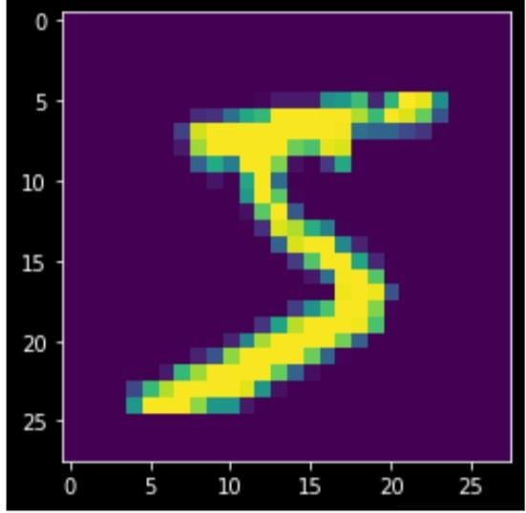

**Data Pre-Processing**

X_train = X_train.reshape(60000, 28, 28, 1).astype('float32')

X_test = X_test.reshape(10000, 28, 28, 1).astype('float32')

number_of_classes = 10

Y_train = np_utils.to_categorical(y_train, number_of_classes)

Y_test = np_utils.to_categorical(y_test, number_of_classes)

Y_train[0]

array([0., 0., 0., 0., 0., 1., 0., 0., 0., 0.], dtype=float32)